SMS System - SMS Gateway
# Source: AI Source: Provided by: [Data Path: Persons Table -> ID Column: 1, Name_En Column: Motasem Essam] -> From: [Chatgpt (GPT‑5 Mini)] on [1/21/2026]
The SMS Gateway is the core component in an SMS system that connects software applications to the mobile carrier networks, enabling the sending and receiving of SMS messages.

📡 What Is an SMS Gateway?
# Source: AI Source: Provided by: [Data Path: Persons Table -> ID Column: 1, Name_En Column: Motasem Essam] -> From: [Chatgpt (GPT‑5 Mini)] on [1/21/2026]
An SMS Gateway is a middleware service that:
- Accepts SMS message requests from an application (via API, HTTP, SMPP, etc.)
- Routes those messages to the appropriate mobile network operator (MNO)
- Returns delivery status updates to the sender
Think of it like a post office that forwards your digital messages to mobile phones.

SMS Gateway photo
https://octopush.com/wp-content/uploads/2021/05/SEO_SMS_Gateway.png
at [7/3/2025]
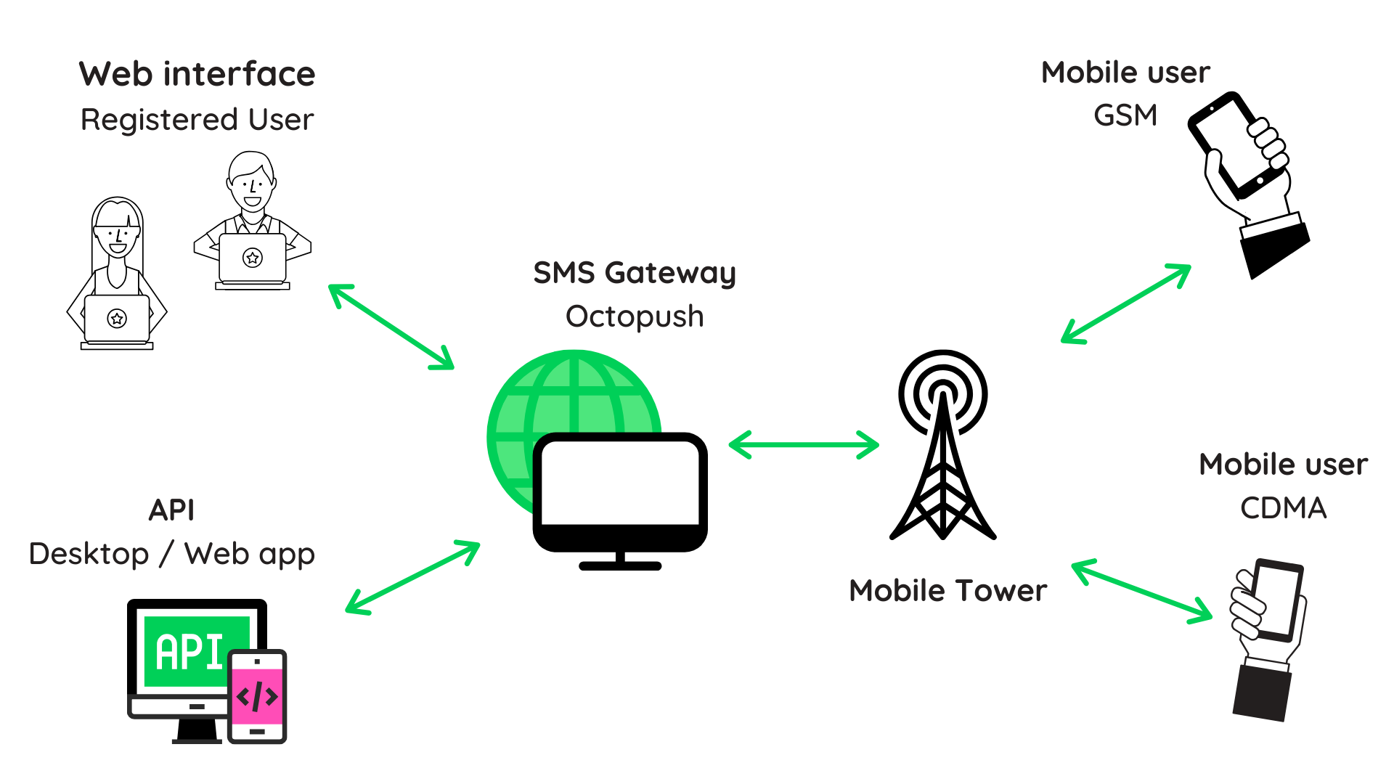

https://www.netfors.com/wp-content/uploads/2014/12/sms-gateway-e1420471251906-1024x496.png
at [7/3/2025]
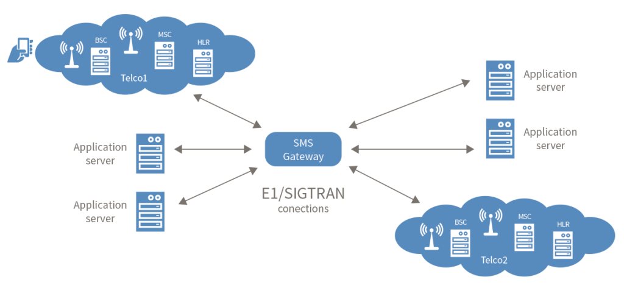

🔁 How It Works
# Source: AI Source: Provided by: [Data Path: Persons Table -> ID Column: 1, Name_En Column: Motasem Essam] -> From: [Chatgpt (GPT‑5 Mini)] on [1/21/2026]
- App/API sends message to the Gateway (HTTP API, SMPP, etc.)
- Gateway validates, formats, and routes the message
- Gateway connects to the SMSC (Short Message Service Center) of the telecom provider
- SMSC delivers to the recipient's phone
- Gateway receives delivery status and sends it back to the system

📦 Key Functions of an SMS Gateway
# Source: AI Source: Provided by: [Data Path: Persons Table -> ID Column: 1, Name_En Column: Motasem Essam] -> From: [Chatgpt (GPT‑5 Mini)] on [1/21/2026]
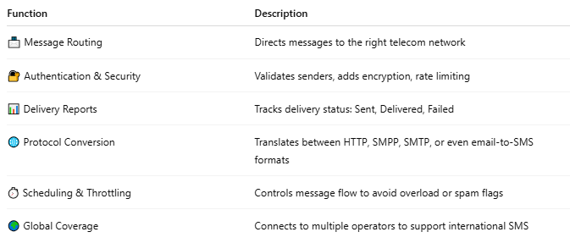

Function | Description
📨 Message Routing | Directs messages to the right telecom network
🔐 Authentication & Security | Validates senders, adds encryption, rate limiting
📊 Delivery Reports | Tracks delivery status: Sent, Delivered, Failed
🌐 Protocol Conversion | Translates between HTTP, SMPP, SMTP, or even email-to-SMS formats
⏱️ Scheduling & Throttling | Controls message flow to avoid overload or spam flags
🌍 Global Coverage | Connects to multiple operators to support international SMS

📘 Common Protocols Used by Gateways
# Source: AI Source: Provided by: [Data Path: Persons Table -> ID Column: 1, Name_En Column: Motasem Essam] -> From: [Chatgpt (GPT‑5 Mini)] on [1/21/2026]
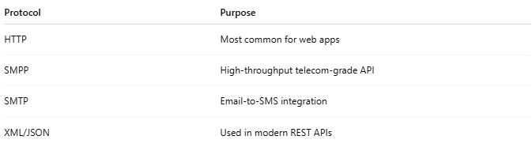

Protocol | Purpose
HTTP | Most common for web apps
SMPP | High-throughput telecom-grade API
SMTP | Email-to-SMS integration
XML/JSON | Used in modern REST APIs

🏢 Examples of SMS Gateway Providers
# Source: AI Source: Provided by: [Data Path: Persons Table -> ID Column: 1, Name_En Column: Motasem Essam] -> From: [Chatgpt (GPT‑5 Mini)] on [1/21/2026]
- Twilio
- Nexmo (Vonage)
- Infobip
- MessageBird
- Africa's Talking
- Plivo

🧑‍💼 Who Uses SMS Gateways?
# Source: AI Source: Provided by: [Data Path: Persons Table -> ID Column: 1, Name_En Column: Motasem Essam] -> From: [Chatgpt (GPT‑5 Mini)] on [1/21/2026]
- App Developers – integrate messaging via APIs
- Enterprises – bulk SMS, alerts, 2FA codes
- Banks – send OTPs and transaction alerts
- Government – emergency and alert systems

